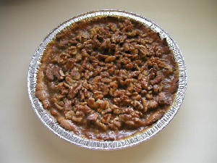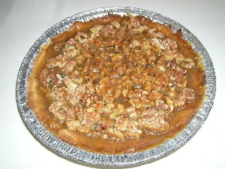

Walnut Tart x4

Tart Shell: 1/3 cup butter or margarine 1 1/3 cup butter
¼ cup granulated sugar 1 cup sugar
1 egg yolk 4 egg yolks
1 cup unsifted all-purpose flour 4 cups flour
½ tsp. vanilla 2 tsp. vanilla

Filling: 2 ¼ cups coarsely chopped walnuts 9 cups walnuts
2/3 cup brown sugar, packed 2 2/3 cup brown sugar
¼ cup butter or margarine 1 cup butter
¼ cup dark corn syrup 1 cup dark corn syrup
2 Tbsp. heavy cream 8 Tbsp. heavy cream

Preheat oven to 375°F.

Make tart shell: Combine butter and sugar until light and fluffy. Add vanilla and egg yolk; beat well. Gradually beat in flour until blended and mixture is crumbly. Form dough with hands into a ball and press evenly into a 9-inch pie pan. Bake in center of oven for 12 minutes, until browned. Cool on a wire rack.

Make filling: Spread chopped nuts onto cookie sheet in a single layer. Bake in 375°F. oven for 5 minutes. Set aside to cool. Sprinkle walnuts in bottom of tart shell. In a saucepan, combine sugar, butter, corn syrup, and cream. Stirring constantly, bring mixture to a boil at medium heat and then boil for 1 minute.

Pour over walnuts. Bake in center of 375°F. oven for 10 minutes, or until mixture is bubbly. Place on wire rack to cool. Serve at room temperature with whipped cream if desired.

Serves 8. Serves 32.

